# The Last decade of Education Institutionalization in India (2001 to 2010)

Education has always been a forward-looking area, from imparting quality education to planning for proper infrastructure to evaluating results on a national level (through Board examinations) to make sure that the nation is well on its way towards a successful future that was envisioned by our forefathers. To understand the past, we must peruse and sometimes analyse the past and strive for a better effort than what has been. There is no better adversary to triumph than one’s own past.

The Education eco-system rests upon 4 main constituent parts:

1. Teachers
2. Students
3. Infrastructure
4. Content Quality

While the first three components can be measured in raw numbers (number of schools, pupils enrolled in various courses, availability & volume of teaching staff etc.); the fourth one is rather qualitative and its relevance is noted upon its demand in the industry, expertise level required & achieved and tools available for developing cognizance towards the subject matter. In the current analyses, I have touched upon a very limited dataset and tried to find the pain-points through simple analysis, because sometimes it’s only a better visualization that is needed to compare and comprehend the need, to spot the outliers and problems, where they lie and what must be done.

I have utilised data from the 8th AISES and Data on number of schools at various regional settings and school types (or level), available on the government of India website (<https://data.gov.in>), released under **National Data Sharing and Accessibility Policy (NDSAP)**, contributed by NITI Aayog / Planning Commission, National Council of Educational Research and Training (NCERT), Ministry of Human Resource Development and Department of School Education & Literacy. I have aggregated the data and transformed it into a form suited for trend analyses. For analyses, visualization and forecasting, I have used Tableau Desktop software, licensed to India Innovation Inc. Private Limited, where I work and I am thankful to them for letting me use the tool for participating in the OpenEd.AI event.

**A little note about the analyses: The data regarding number of schools is available till 2010 (as in 8th AISES). Hence, the metrics and trends are a little stale for 2017. Nevertheless, it is to be treated only as an indicator of the last decade of institutional progress and decisions are to be taken based on more relevant and latest data.**

I have submitted, along with this summary:

1. An Excel sheet containing all the aggregated data
2. A Tableau Packaged Workbook, which contains interactive visualizations and can be opened using the latest version of their free tool – Tableau Reader.
3. A PDF file containing snapshots of visualizations, so that the reader can have an overview of the results.

Now, let’s take up the analyses one by one (it is prudent that the reader opens the PDF file and/or Tableau Packaged workbook for quick reference as I explain):

**Tab:** # School per Type

**PDF Page:** 1

**Description:** The pie chart simply shows that approximately 85% schools cater to Primary & Upper Primary levels of education. After completing class 8th, there is a great shortage of institutions that can cater to Secondary & Upper Secondary education. As an after effect, students come to rely on non-schooling educational settings such as Private Tuition and Coaching.

**Tab:** # School per State per Type

**PDF Page:** 2, 3

**Description:** This shows distribution of schools per type (denoted by colour) in each State/UT. At a glance, it is evident that everywhere, number of Primary schools is high. In some states such as Andhra Pradesh, Karnataka & Maharashtra, there is relatively good number of secondary schools but other states such as Arunachal Pradesh, Chhattisgarh, Jharkhand etc., there are barely enough secondary schools to sustain the pupil base who complete their education till class 8th. The direct result of this being that students migrate to states/cities where these facilities are available to pursue secondary education.

**Tab:** Area (sq. Km) per school

**PDF Page:** 4

**Description:** The number of schools is not a good indicator when taken individually. We must assess if they fulfil the need of the population in the state. One method is to see how large an area is catered by a school on an average in a state. A much finer analysis would be to find what is the population density at various places and if it is being catered by our schools. Currently, I have tried to see what is the average area catered per school in sq. Km in each state. A large Area/school ratio suggests that a larger area is catered per school, which increases the population burden of students which must be accommodated. Of course, in area like Arunachal Pradesh, where the population density is low, this metric doesn’t make sense. But in metropolitan cities/states this indicates if students would be travelling a long distance to access the school. This stat is more important for Secondary schools, which have a sparse presence as compared to Primary Schools. Summary of Secondary & Higher Secondary Schools-Area ratio:

1. Central Region: UP has the best ratio of having a school for each 27.62 sq. Km, which Chhattisgarh has the worst ratio as 1 school per 57.46 sq. Km.

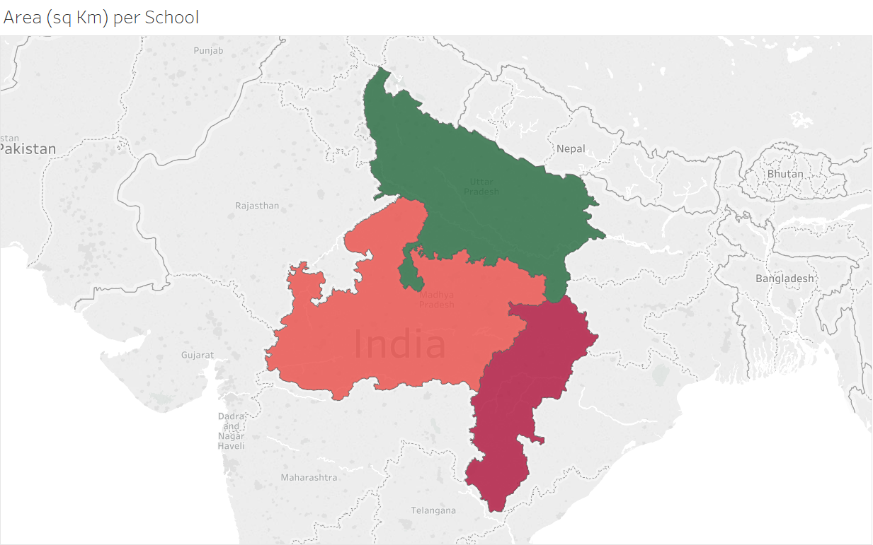

1. Eastern Region: West Bengal performs the best at 1 school per 20.19 sq. Km, which Odisha has the worst ratio at 1 School per 69.97 sq. Km.

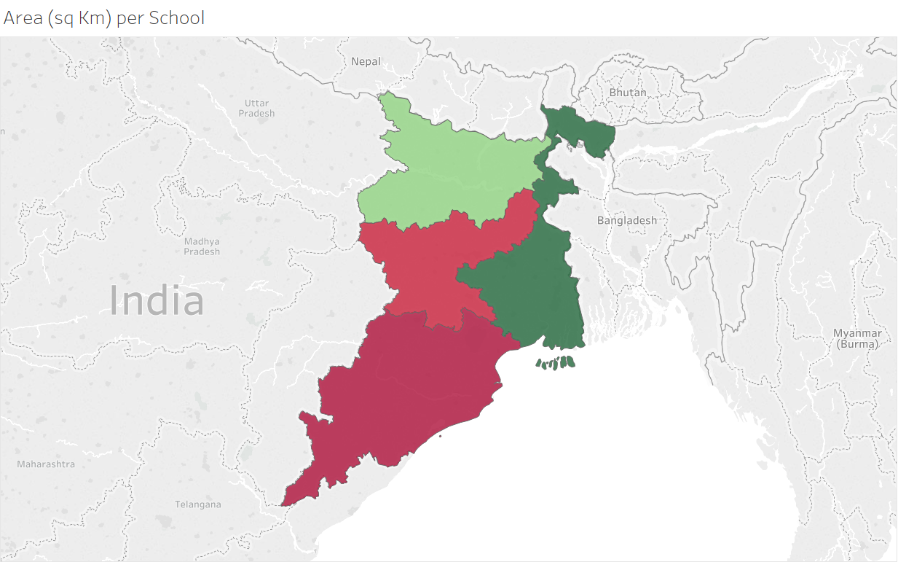

1. North-Eastern Region: Neglecting Arunachal Pradesh because of topographic concerns, Tripura has the best ratio of 1 School per 26.01 sq. Km while Nagaland has 1 School per 144.74 sq. Km. It is worth noticing that in the North-Eastern region, geography and population density become a major factor and Area/School ratio may not be equally relevant as in regions like Delhi-NCR.

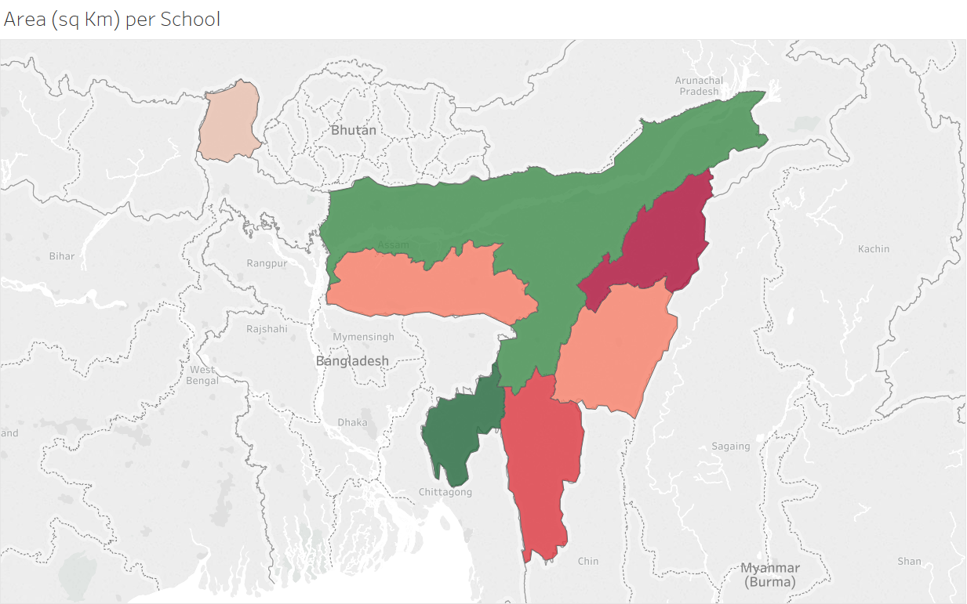

1. Northern region: Chandigarh performs best with 1 School per 1.72 sq. Km with Delhi at a close 1 school per 2.09 sq. Km. J&K, Himachal Pradesh, Uttarakhand & Rajasthan have geographical constraints; hence a higher ratio is expected.

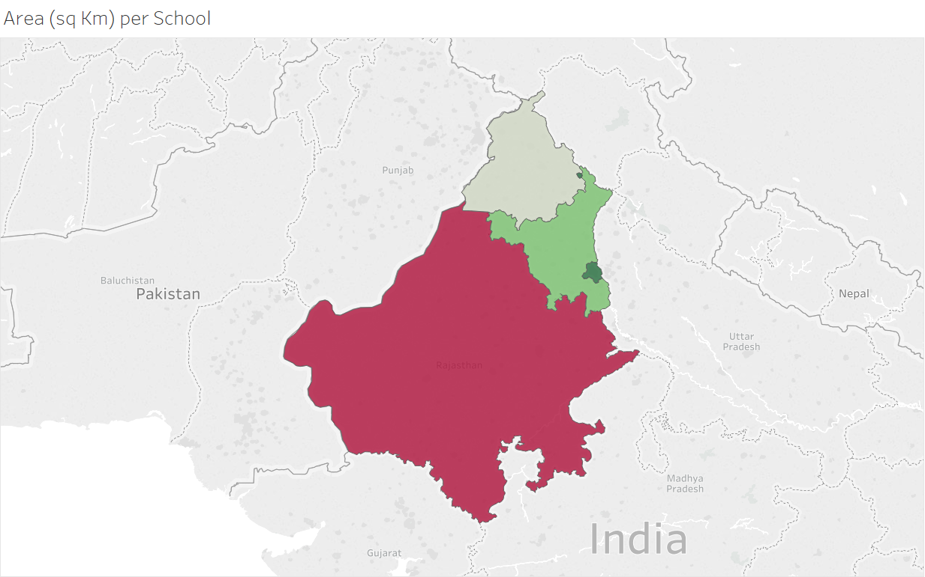

1. Southern: Andhra Pradesh performs best with 1 school every 20.18 sq. Km while Tamil Nadu has the highest value at 1 School per 38.66 sq. Km.

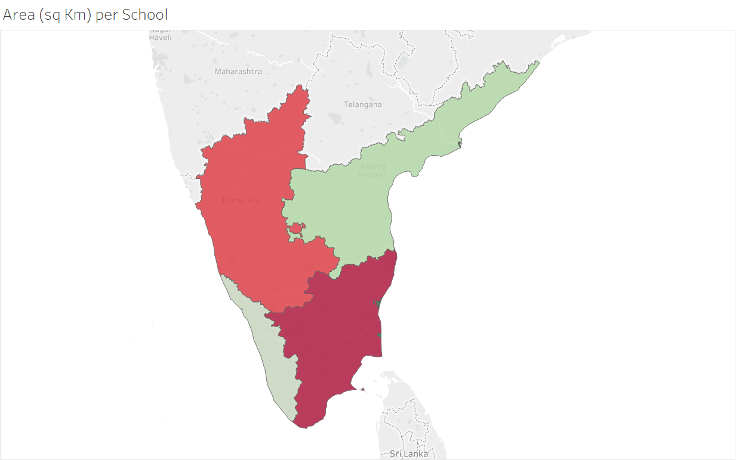

1. Western: UT of Daman & Diu (for its small area) and Gujarat (due to missing data in the dataset) are ignored. Maharashtra has the highest ratio with 1 School per 40 sq. Km while Goa has the lowest with 1 school per 27.47 sq. Km.

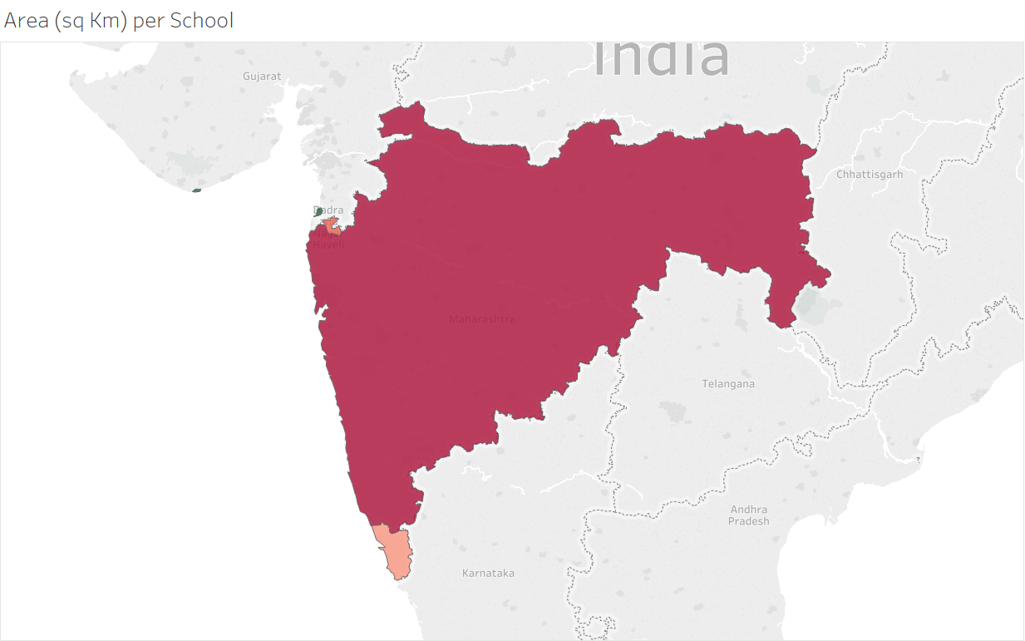

**Tab:** School Coverage

**PDF Page:** 5, 6, 7, 8

**Description:** This is a tabular representation of data with metrics such as State area (sq. Km), School Type, number of schools in 2009 and 2010 and ratio of Area catered by each school. The states are ordered in descending order of the average of (area/school).

The overall scenario being North-Eastern regions don’t have so many schools, followed by Eastern regions like Jharkhand and Chhattisgarh. The result being that while Eastern, North-Eastern and Western regions come out to be potential source of student migration; Northern regions of Delhi-NCR and Southern regions become favoured destinations of the educational journey. This trend mimics the student migration pattern (even after higher secondary) as presence of educational institution becomes a driving force. Why this pattern is so import to analyse is discussed at the very last (Summary section) of this report.

**Tab:** Growth in no. of Schools between 2009-2010 & Change in no. of Schools between 2009-2010 (Statewise)

**PDF Page:** 9, 10

**Description:** The next 2 tabs show which states have strived or achieved a growth in the number of institutions towards the end of the last decade. UP has added the highest number of schools (17k approx.) in that year (2009-2010) while West Bengal has closed the highest number of schools (25k approx.). Why this has happened deserves a finer analysis of the Root-Cause.

**Tab:** # Teachers (8th AISES)

**PDF Page:** 11, 12

**Description:** Teachers form a very important part of any education eco-system; hence, the number of teachers in employment signifies the workforce that shape our nation’s future. Again, quality in terms of ability, training and performance hasn’t been analysed. Only raw numbers have been considered.

Uttar Pradesh, Maharashtra, Andhra Pradesh, Madhya Pradesh and Rajasthan boast more than 5 lac teachers each. Also, more teachers are employed in rural regions than urban regions.

**Tab:** # Teachers in Rural / Urban setting (8th AISES)

**PDF Page:** 13

**Description:** This is a scatter plot of Full time vs Part-time/Contract teachers in various states in rural and urban regions. Uttar Pradesh employs a very high number of both. States like Jharkhand & Chhattisgarh have more teachers in Part-time/Contract than Full time. If the requirement is permanent, the positions can be converted into Full time. This might be one of the factors that ensure stability for the teachers and benefits students in these areas; because from our previous analyses, we know that the number of schools is less in these states. If the vacancies go unfulfilled, the student base suffers and quality of education suffers.

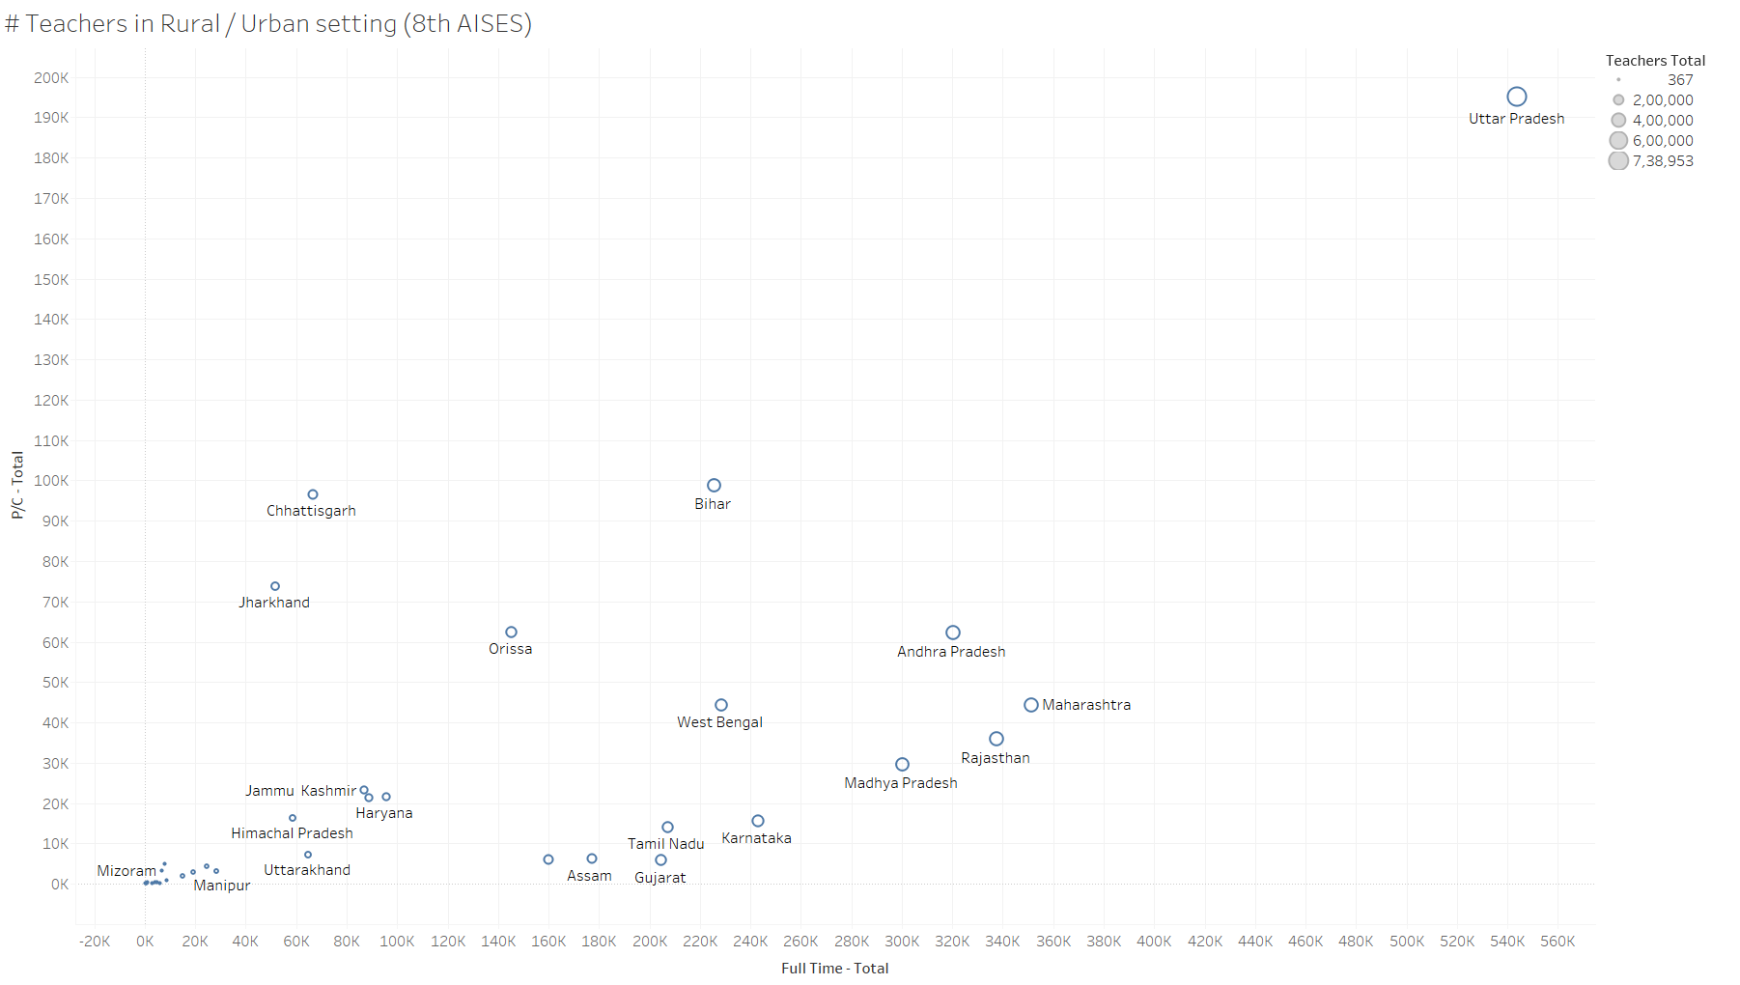

In urban setting, most employments are Full-time and more stable than their rural counter-parts. More number of schools also ensure that teachers have growth prospect in urban regions, while due to lack of opportunities, teachers in rural region might become complacent towards their duties and healthy competition that may drive growth of community as a whole.

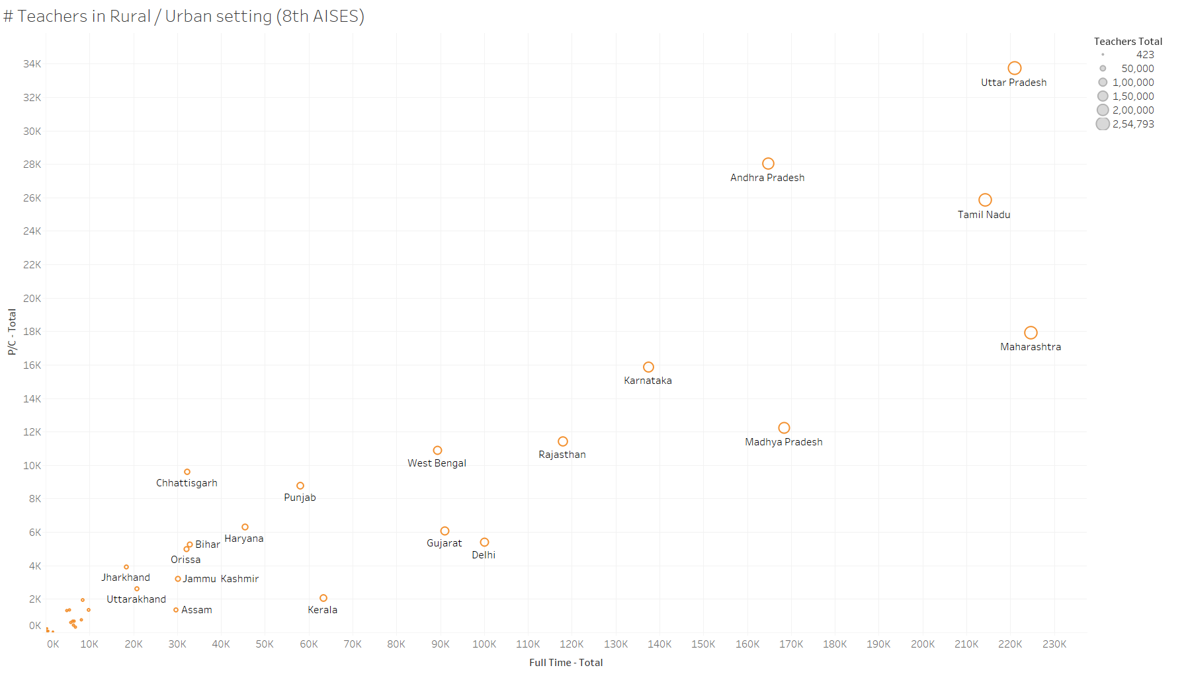

**Tab:** # Schools forecast (Overall) & # Schools forecast (state wise)

**PDF Page:** 14, 15

**Description:** This is the growth trend of number of schools (all types) between 2001 and 2010. Based on the growth trend, a forecast has been created (linear) which predicts that we should have approx. 17 lac schools in 2017 (window between 15 lakhs to 18 lakhs).

If we have achieved that number, we have at least maintained that growth trend. The trend per state is shown on the last tab along with the state-wise forecast.

## Summary

The following points emerge from the analysis:

1. There is a huge lack of Secondary & Higher Secondary schools (only 15%) to Primary & Upper Primary schools (85%). So, a lot of students who complete Primary education would find it difficult to access Secondary education and would rely on private tuitions & Coaching. These private tuitions and coaching classes are not recognised / registered and hence, there is no regulation. Although, they serve to fill gaps in education quality, left while teaching at schools.
2. States in Northern region (Delhi-NCR, Rajasthan) and Southern India (Andhra Pradesh, Tamil Nadu) serve as destination for student migrating towards higher education, from North-Eastern and Eastern states due to presence of institutions. This adds to the cost of education through additional cost of finding a lodging, food etc. This cost becomes substantial when the migration is towards institutes offering Graduation & PG courses. Education loans are provided to students who can’t afford the fees and the additional cost of sustenance at a new place puts additional burden on the student.
3. Jharkhand and Chhattisgarh have more Part-time/Contract teachers than Full-time. There is an inherent stability associated with a Full time position and ensures stickiness. When Contractual positions are created with the promise to make them permanent and the plan runs into trouble, conflict often emerges, impacting the students in those regions. Hence, a strategy is needed to systematically convert contractual positions into full time. The need is already there. It is best that at least the workforce is stabilized.
4. Jharkhand shows great potential for growth in the number of institutions till 2017. While Kerala seems to have reached saturation. For saturated states, focus should be on the quality of education while for states with high Area/school ratio, focus needs to be given on increasing more schools.
5. Punjab has shown slow decline in number of schools and the forecast suggests this to continue. Attention needs to be paid to finding the Root-Cause of the trend and remove any blockers to the development.